PAEROA COLLEGE SCHOOL UNIFORM PRICES

Junior Uniform Yr9 – Yr11
Junior Boys Shorts | 61 – 120 | $40.00
Junior Boys Short Sleeve Shirt | XS – 4XL | $45.00
Junior Girls Skirt | 6 - 24 | $50.00
Junior Girls Short Sleeve Blouse | 6 - 24 | $45.00
Senior Uniform Y12 – Y13
Senior Boys Shorts | 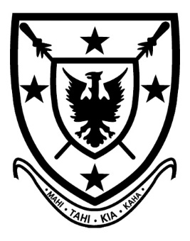  64 - 112 | $40.00
Senior Boys Long Black Pants | 76 - 104 | $65.00
Senior Boys Short Sleeve Shirt | XS – 4XL | $45.00
Senior Boys Long Sleeve Shirt | XS – 2XL | $55.00
Senior Girls Skirt | 6 – 24 | $50.00
Senior Girls Short Sleeve Blouse | 6 – 24 | $45.00
Soft Shell Jacket | Ladies: S – 2XL Mens: S – 5XL | $75.00
PE House Shirts | XS – 2XL | $25.00
Socks - Black |  | $15.00
Hat - |  | $18.00

Please note:
- If you need a size made other than the standard sizes there is a 30% surcharge.
- If we need to order items in quickly they will be made in NZ and the cost reflects this. Prices are as below for NZ made items
Senior Boys Short Sleeve Shirt $55.00
Junior Boys Short Sleeve Shirt $55.00
Senior Girls Short Sleeve Blouse $60.00
Junior Girls Short Sleeve Blouse $60.00

